🔹 Method Overloading (Clean & Correct Explanation)

✅ What is the need for Method Overloading?
Suppose we want to add numbers, but the inputs can come in many combinations:
- 2 int numbers
- 3 int numbers
- 2 int + 1 float
- 2 float + 1 int
- 3 float numbers
- 2 float numbers
- 2 double numbers
- 2 double + 1 float
…and so on.
If we create different method names for every case (like addInt(), addFloat(), addDouble() etc.):
- Code becomes lengthy
- Naming becomes confusing
- Maintenance becomes difficult
- Class readability reduces
👉 This is inefficient and unnecessary.

✅ Why Method Overloading is used
Method overloading solves this problem.
Instead of writing many methods with different names, we write:
➡️ Multiple methods with the same name
➡️ But with different parameter lists
This way:
- Code becomes clean
- Logic stays organized
- One method name can handle many cases

🔹 Definition of Method Overloading
Method overloading means writing more than one method with the same name but different parameters, within the same class.

Parameters must differ by:
- Number of parameters
- Data type of parameters
- Order (sequence) of data types

Eg: Method_Overloading

🔹 One : Many Concept
- One method name
- Many implementations
- Same action, different input forms
👉 One method performs multiple related activities

🔹 Compile-Time Polymorphism (Early Binding)
Method overloading is also called:
- Compile-time polymorphism
- Early binding

Why?
Because the compiler decides which method to call before execution.

🔹 How compiler resolves overloaded methods (Step-by-step)
When execution starts from the main() method:
1️⃣ Compiler reads code line by line
2️⃣ It checks:
- Syntax correctness
- Object creation validity
3️⃣ When a method call is found:
obj.add(10, 20);
4️⃣ Compiler looks for methods with:
- Same method name
- Then checks:
  - Number of parameters
  - Data types of parameters
  - Order of data types
5️⃣ The method that exactly matches the arguments is selected
6️⃣ That method is bound at compile time and executed
👉 All this happens before runtime, so it is compile-time polymorphism.

🔹 Meaning of Polymorphism (Simple)
- Poly → many
- Morphism → forms
👉 Polymorphism = many forms
Here:
- Same method name
- Many forms based on parameters

🔹 Important Rule: Return Type Has NO Role
⚠️ Return type is NOT considered in method overloading.
The compiler only considers:
- Method name
- Parameter list

Eg: Method_Overloading_Eg2
// go through the code

Eg: Method_Overloading_With_Implicit_TypeCasting
// go through the code

Eg: Method_Overloading_Eg3
// go through the code

🔹 Important Rule: Return Type Has NO Role
⚠️ Return type is NOT considered in method overloading.
The compiler only considers:
- Method name
- Parameter list

❌ Invalid Overloading Example (Conceptually)
If two methods have:
- Same name
- Same parameters
- Only different return type
👉 Compile-time error will occur
Because compiler cannot differentiate methods using return type.

🔹 println() — Real-Time Example of Method Overloading
println() is a perfect real-world example of method overloading.
Internally, Java has many println() methods like:
- println(int)
- println(float)
- println(double)
- println(String)
- println(Object)
Same method name → different parameters → different behavior

🔹 Implicit Type Casting & Overloading (Important Missing Point Added)
When exact match is not found, compiler may apply:
👉 Implicit type casting (widening)
Example idea:
- int → float
- float → double
⚠️ But:
- Compiler always prefers exact match
- Widening happens only if exact match is not available
- Narrowing is never allowed
(You said you will provide code later — this explanation matches that case.)

🔹 Final Key Rules (Interview Gold)
✅ Method overloading happens within the same class
✅ Method name must be same
✅ Parameter list must be different
✅ Return type is ignored
✅ Happens at compile time
✅ Improves code readability and reusability

🧠 One-Line Interview Definition
👉 Method overloading allows multiple methods with the same name but different parameter lists, and the compiler decides which method to call at compile time.

Array

Why do we need an Array?
Suppose you want to store 100 integer numbers.

Without Array (Wrong Way)
• One way is to create 100 different variables like:
num1, num2, num3, … num100
This is not a good idea because:
1️⃣ It is very hard to remember so many variable names.
2️⃣ Writing the program becomes very long and confusing.
3️⃣ Doing operations like searching, sorting, adding numbers becomes very difficult.

✅ Solution → Use an Array
• An array allows us to store many values using one single name.
• All values are stored in order and are accessed using numbers called indexes.

Example in Java
int numbers[] = new int[100]; // creates an array that can store 100 integers
• numbers is one array variable
• It can store 100 integer values
numbers[0] = 10; // first value
numbers[1] = 20; // second value
👉 So instead of creating 100 variables, one array is enough.

What is an Array? (Simple Meaning)
• An array is a way to store many values of the same type together.
• Each value has a number (index) to identify its position.
• All values are accessed using one name and an index number.

Important Rules about Array
• All values in an array must be of the same type
(only int, or only double, or only String, etc.)
• In Java, an array is treated as an object.
• Since arrays are objects, they are stored in heap memory.

How Array is Created (Step by Step)

Step 1: Create array object using new
new int[5]
• int → type of values we want to store
• 5 → how many values we want to store

Step 2: Give a name to the array
int[] a = new int[5];
• int[] → tells Java that a is an array of integers
• a → name of the array
• new int[5] → creates space for 5 integer values

Accessing Values using Index
• Array uses square brackets [ ]
• Index always starts from 0
Example:
a[0] = 10; // first value
a[1] = 20; // second value

Storing Values in Array
• If array size is 5, valid index numbers are:
0, 1, 2, 3, 4
• Syntax to store a value:
a[index] = value;
Example:
a[2] = 50; // stores 50 at position 2

Getting (Retrieving) Values from Array
• To get a value, use the index again:
a[index]
Example:
System.out.println(a[2]); // prints the value at index 2

🧠 Very Simple One-Line Summary
👉 An array is used to store many values of the same type using one name and index numbers.

( array internal memory map if the reference is a local variable)
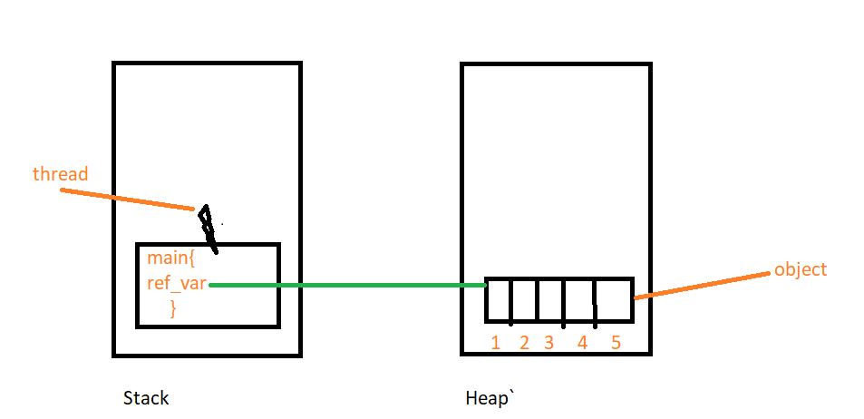

Single Dimensional Array (1-D Array)
• When we create an array in Java, the array object is always created in heap memory.
• The reference variable is stored based on where it is declared.
• If the reference is a local variable, it is stored in stack memory.

Memory Areas Used (Local Reference Case)

1️⃣ Stack Memory
• Stores the reference variable (array name).
• Example:
int[] a = new int[5];
• Here, a is a local reference variable, so it is stored in the stack.

2️⃣ Heap Memory
• Stores the actual array object.
• The array object contains:
- Values
- Size information
- Type information
• The reference variable in stack points to the array object in heap.

In the Diagram
• Stack box → contains the reference variable a.
• Heap box → contains the array object with 5 blocks.
• Valid indexes are 0, 1, 2, 3, 4
(diagram shows 1–5, but Java indexes start from 0).
📌 This diagram represents the internal memory layout when the array reference is a local variable.

🧠 One-Line Gold Summary
👉 An array object is always created in heap memory, and its reference variable is stored according to its scope.

✅ FIRST: Your understanding is 100% CORRECT
You said:
if the reference variable is local → stored in stack
if the reference variable is instance → stored inside the object (heap)
if the reference variable is static → stored in method area
in all cases → object is created in heap
✔️ This is absolutely correct. No mistake here.

🧠 Then why did I say:
“array reference variable is stored in stack memory”?
Because that statement was made under a specific context.
Let us clarify 👇

🔹 Context Matters (THIS is the key)
Consider this code:
class Test {
public static void main(String[] args) {
int[] a = new int[5];
}
}

What is a here?
- a is declared inside main()
- main() is a method
- Variables declared inside a method are local variables
📌 Therefore:
👉 a is a local reference variable
✔️ So in THIS CASE:
- Reference → Stack
- Array object → Heap
That is why I said stack.

🔹 Now let us test your rules one by one (with examples)

✅ Case 1: Local reference variable (Stack)
void test() {
int[] a = new int[5];
}
✔️ a is local
✔️ Stored in stack
✔️ Object in heap

✅ Case 2: Instance reference variable (Heap)
class Test {
int[] a = new int[5];
}
✔️ a is an instance variable
✔️ Stored inside the object
✔️ Object itself is in heap
📌 Heap → Object → Reference → Array object

✅ Case 3: Static reference variable (Method Area)
class Test {
static int[] a = new int[5];
}
✔️ a is static
✔️ Stored in Method Area
✔️ Array object still in heap

🔑 UNIVERSAL RULE (Memorize this)
📌 Where the reference variable is stored depends on how it is declared, NOT on what it refers to.
Reference Type | Stored In
Local | Stack
Instance | Heap (inside object)
Static | Method Area
Object (always) | Heap

❗ Why confusion happens
When people say:
“Array reference is stored in stack”
They actually mean:
“Array reference declared as a local variable is stored in stack”
❌ The shortened sentence causes misunderstanding.

🧠 Final Correct Statement (Perfect Version)
👉 In Java, an array object is always created in heap memory.
The reference variable pointing to that array is stored in stack, heap, or method area depending on whether it is declared as local, instance, or static.

🥇 One-Line Interview Gold (Zero Confusion)
👉 Objects are always created in heap; reference variables are stored based on their scope.

Why Single Dimensional?
• It is called single dimensional because only one index (one dimension) is needed to access each element.
• Elements are stored in a linear (one-level) structure, not in rows and columns.

Example:
int[] a = new int[5];
• a[0], a[1], a[2], a[3], a[4]
• Only one index is used → so it is 1-D array

🔁 About Rows & Columns (Clarification)
• If we need two indexes (row and column), then it becomes a two-dimensional array
Example:
int[][] a = new int[3][4];
• Accessed as a[row][column]
• Requires two indexes
• Hence called 2-D array

🧠 One-Line Gold Definition
👉 An array is called single dimensional because it uses only one index to access elements.

⚖️ Quick Comparison
Array Type | Index Used | Structure
1-D array | One index | Linear
2-D array | Two indexes | Array of arrays
3-D array | Three indexes | Multiple levels

📘 Two-Dimensional Array (2D Array)

🧠 CORE POINT (Memorize This)
👉 A 2D array in Java is accessed using two indexes because it has two levels of indexing.
That’s the heart of the concept.

🔍 Explain the Core Point (Slow & Clear)

What does “two levels of indexing” mean?
• A 2D array does not store values directly at the first level.
• The first level stores references to other arrays.
• The second level stores the actual values.
That is why two indexes are required.

🧩 How indexing works (Step-by-step thinking)
int[][] arr = new int[3][5];

Step 1: First index
arr[0]
• This does not give a number
• It gives an inner array
So:
👉 First index → selects which array

Step 2: Second index
arr[0][2]
• Now we go inside that selected array
• This gives the actual value
So:
👉 Second index → selects value inside the array

🔑 Why it is called “Two-Dimensional”
• One index is not enough
• We need:
- One index to choose the inner array
- One index to choose the value inside it
📌 Two indexes = Two dimensions

🧠 One-Line Memory Hook (Very Strong)
👉 First index chooses the array, second index chooses the value.
Remember this line — it will never fail you.

❌ What NOT to remember (to avoid confusion)
❌ Rows and columns
❌ Tables and matrices
These are only visual help, not the real reason.

✅ Final Perfect Definition (Exam + Interview Safe)
👉 A 2D array in Java is an array that stores references to other arrays, so two indexes are needed—one to select the inner array and one to select the value inside it.

2️⃣ Syntax in Java (Core Idea First)

🧠 CORE IDEA
👉 A 2D array has two sizes because it has two levels.
Now apply this idea to the syntax.
int[][] arr = new int[3][5];

What does this really mean?
• 3 → how many inner arrays we want
• 5 → how many values each inner array can store
📌 So this tells Java:
- Create 3 separate arrays
- Each array can store 5 integers

Memory meaning (important to remember)
👉 It does NOT mean:
- One table of 15 values
👉 It DOES mean:
- 3 arrays × 5 values each

3️⃣ How 2D Array is Stored in Memory (Very Important)

🧠 CORE IDEA
👉 A 2D array is created in two steps in heap memory.

Stack Memory (Simple Rule)
• Stack stores only the reference variable
• arr is just a name that points to heap
arr → heap

Heap Memory (Step-by-Step Creation)

Step 1: Outer array is created
• Java creates one array of size 3
• This array stores 3 references, not values
Think like this:
👉 Outer array = list of addresses

Step 2: Inner arrays are created
• Each reference points to a separate inner array
• Each inner array has 5 integer slots
So heap memory looks like:
arr (stack)
↓
Heap:
Index 0 → [ ] [ ] [ ] [ ] [ ]
Index 1 → [ ] [ ] [ ] [ ] [ ]
Index 2 → [ ] [ ] [ ] [ ] [ ]

📌 Important Points to Lock in Memory
✔️ Inner arrays are independent objects
✔️ Java does not store 2D arrays as one big block
✔️ Each inner array lives separately in heap

4️⃣ Example Usage (Understand Indexing Clearly)
arr[0][2] = 50;

How Java reads this:
1️⃣ arr[0]
→ select the inner array at index 0
2️⃣ arr[0][2]
→ select position 2 inside that array
3️⃣ = 50
→ store value 50

In very simple words:
• Group = 0
• Position = 2
• Value = 50

5️⃣ When Should We Use a 2D Array?

🧠 CORE IDEA
👉 Use a 2D array when data has two levels of grouping.
Examples:
• Classes → Students
• Departments → Employees
• Cities → Areas
• Rows → Columns
If data needs:
- One index → 1D array
- Two indexes → 2D array

⚠️ Small but Very Important Clarification

❌ Wrong thinking
A 2D array is a table in memory

✅ Correct thinking
A 2D array is an array that stores references to other arrays
That is why:
• Rows can have different sizes
• Java allows this:
int[][] arr = new int[3][];
arr[0] = new int[2];
arr[1] = new int[5];
arr[2] = new int[1];
Each inner array:
✔️ Is created separately
✔️ Can have different length

🧠 One-Line Gold Summary (Memorize This)
👉 A 2D array in Java is an array that stores references to other arrays, so each inner array is a separate object in heap memory.

📘 Memory Representation of 2D Array in Java

Example:
int[][] arr = new int[3][5];
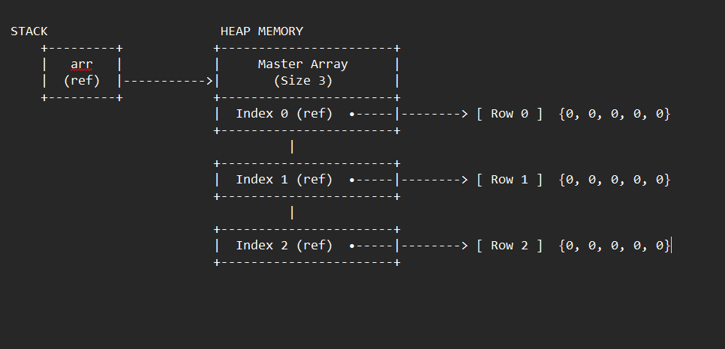

🧠 Core Idea (Must Remember)
👉 A 2D array in Java is not a single block of memory.
👉 It is one outer array that stores references to multiple inner arrays.
This memory map shows that clearly.

1️⃣ Stack Memory (Left Side)
• Stack contains only the reference variable arr.
• arr does not store data.
• arr only points to an array object in heap.
📌 In the diagram:
STACK ( if arr is a local variable, the memory for ref is stored based on type of variable)
arr (ref)
✔️ This is correct because arr is a local variable.

2️⃣ Heap Memory – Outer Array (Master Array)
• Heap stores the actual array objects.
• First, Java creates one outer array of size 3.
📌 In the diagram:
Master Array (Size 3)
• This outer array does not store integers.
• It stores 3 reference slots:
- Index 0 (ref)
- Index 1 (ref)
- Index 2 (ref)
👉 Each slot can point to an inner array.

3️⃣ Heap Memory – Inner Arrays (Rows)
• After creating the outer array, Java creates 3 inner arrays.
• Each inner array has 5 integer elements.
📌 In the diagram:
Index 0 (ref) → [ Row 0 ] {0, 0, 0, 0, 0}
Index 1 (ref) → [ Row 1 ] {0, 0, 0, 0, 0}
Index 2 (ref) → [ Row 2 ] {0, 0, 0, 0, 0}
✔️ Each row is a separate array object in heap.
✔️ All values are 0 by default (because int default value is 0).

4️⃣ Important JVM Observations (Very Important)

🔹 Default Values
• All int elements are initialized to 0.
• This happens automatically by JVM.

🔹 Separate Objects
• Each row is a different array object.
• Rows are not stored together as one big block.
👉 This is why Java supports jagged arrays.

🔹 Two-Level Structure
• First level → references (outer array)
• Second level → actual data (inner arrays)
This is why two indexes are needed:
arr[rowIndex][columnIndex]

5️⃣ How Access Works (From This Memory Map)
Example:
arr[1][3] = 50;
Step-by-step:
1️⃣ arr[1] → go to Index 1 reference
2️⃣ Follow that reference to Row 1 array
3️⃣ [3] → go to index 3 in Row 1
4️⃣ Store value 50

6️⃣ Why This Is NOT a True Table
❌ Java does NOT store 2D arrays like a table or matrix
✅ Java stores them as array of array references
That is why this is valid:
int[][] arr = new int[3][];
arr[0] = new int[2];
arr[1] = new int[5];
arr[2] = new int[1];

🧠 One-Line Gold Note (Write Below Diagram)
👉 In Java, a 2D array is implemented as one outer array of references pointing to multiple inner array objects stored separately in heap memory.

📘 Three-Dimensional Array (3D Array)

🧠 CORE POINT (Memorize This)
👉 A 3D array in Java is accessed using three indexes because it has three levels of indexing.
This is the heart of the concept.
If you remember this, everything else becomes easy.

🔍 Explain the Core Point (Slow & Clear)

What does “three levels of indexing” mean?
• A 3D array does not store values directly at the first level.
• The first level stores references to 2D arrays.
• The second level stores references to 1D arrays.
• The third level stores the actual values.
📌 That is why three indexes are required.

🧩 How Indexing Works (Step-by-Step Thinking)

Example:
int[][][] arr = new int[3][4][3];

Step 1️⃣: First index
arr[0]
• This does not give values
• It gives a 2D array
So:
👉 First index → selects which 2D array

Step 2️⃣: Second index
arr[0][1]
• This does not give a value
• It gives a 1D array
So:
👉 Second index → selects which 1D array

Step 3️⃣: Third index
arr[0][1][2]
• Now we are inside the 1D array
• This gives the actual value
So:
👉 Third index → selects the value

🔑 Why it is called “Three-Dimensional”
• One index is not enough
• Two indexes are not enough
• We need:
- One index to choose the 2D array
- One index to choose the 1D array
- One index to choose the value
📌 Three indexes = Three dimensions

🧠 One-Line Memory Hook (Very Strong)
👉 First index chooses the 2D array, second index chooses the 1D array, third index chooses the value.
If you remember this line, you will never get confused.

❌ What NOT to Remember (Avoid Confusion)
❌ Boxes, tables, cubes
❌ Physical shapes
These are only visual help, not the real reason.

✅ Final Perfect Definition (Exam + Interview Safe)
👉 A 3D array in Java is an array that stores references to 2D arrays, which store references to 1D arrays, so three indexes are required to reach the actual value.

2️⃣ Syntax in Java (Core Idea First)

🧠 CORE IDEA
👉 A 3D array has three sizes because it has three levels.
Now apply this to the syntax:
int[][][] arr = new int[3][4][3];

What does this really mean?
• 3 → how many 2D arrays we want
• 4 → how many 1D arrays inside each 2D array
• 3 → how many values inside each 1D array
📌 So this tells Java:
• Create 3 separate 2D arrays
• Each 2D array contains 4 separate 1D arrays
• Each 1D array can store 3 integers

Memory Meaning (Important)
👉 It does NOT mean:
• One big block of 3 × 4 × 3 values
👉 It DOES mean:
• Many small arrays connected by references

3️⃣ How 3D Array is Stored in Memory (Very Important)

🧠 CORE IDEA
👉 A 3D array is created in three steps in heap memory.

Stack Memory (Simple Rule)
• Stack stores only the reference variable
• arr is just a name pointing to heap
arr → heap

Heap Memory (Step-by-Step Creation)

Step 1️⃣: Outer array is created
• Java creates one array of size 3
• This array stores references to 2D arrays
👉 Think like this:
Outer array = list of addresses

Step 2️⃣: Middle arrays are created
• Each reference points to a 2D array of size 4
• These arrays store references to 1D arrays

Step 3️⃣: Inner arrays are created
• Each reference points to a 1D array of size 3
• These arrays store actual integer values

Heap Memory Looks Like This:
arr (stack)
↓
Heap:
Level 1 → 3 references (2D arrays)
Level 2 → each has 4 references (1D arrays)
Level 3 → each has 3 int values

📌 Important Points to Lock in Memory
✔️ Every level is a separate array object
✔️ Java does not store 3D arrays as one block
✔️ All arrays are stored in heap memory
✔️ Only the reference is stored in stack

4️⃣ Example Usage (Understand Indexing Clearly)
arr[0][1][2] = 85;
How Java reads this:
1️⃣ arr[0]
→ select the 2D array at index 0
2️⃣ arr[0][1]
→ select the 1D array at index 1
3️⃣ arr[0][1][2]
→ select position 2 and store 85

In very simple words:
• Level-1 group = 0
• Level-2 group = 1
• Value position = 2
• Stored value = 85

5️⃣ When Should We Use a 3D Array?

🧠 CORE IDEA
👉 Use a 3D array when data has three levels of grouping.
Examples:
• Country → State → City
• College → Class → Student
• Company → Department → Employee
• Book → Chapter → Page

⚠️ Small but Very Important Clarification (Mistake Fix)
❌ Wrong thinking
A 3D array is a cube in memory
✅ Correct thinking
A 3D array is an array of arrays of arrays
That is why Java allows uneven sizes:
int[][][] arr = new int[3][][];
arr[0] = new int[2][];
arr[1] = new int[4][];
arr[2] = new int[1][];
Each level:
✔️ Is created separately
✔️ Can have different length

🧠 One-Line Gold Summary (Memorize This)
👉 A 3D array in Java is an array that stores references to 2D arrays, which store references to 1D arrays, so each level is a separate object in heap memory.

Memory representation of 3d – array
int[][][] arr = new int[3][4][3]
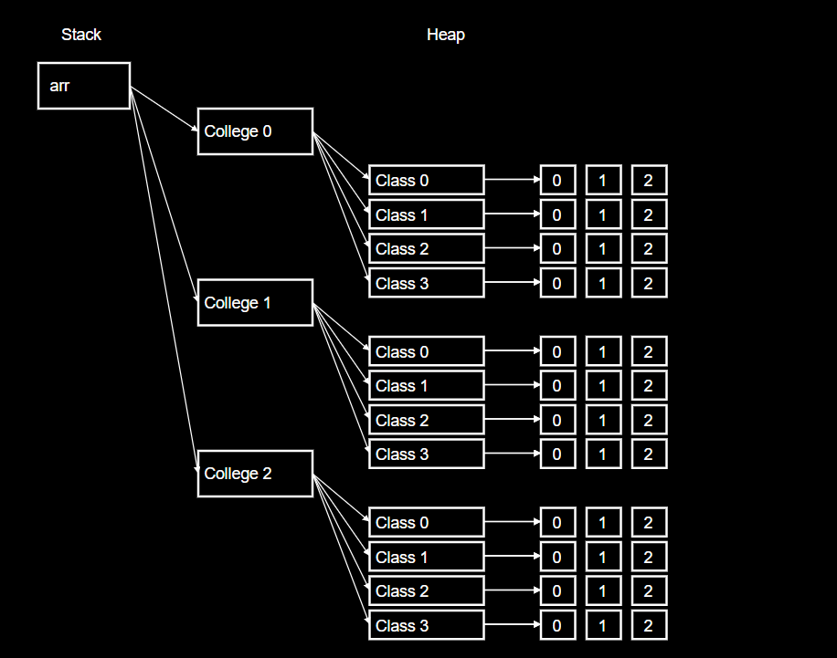

📘 Two-Dimensional Jagged Array (Jagged 2D Array)

🧠 CORE POINT (Memorize This – MOST IMPORTANT)
👉 A jagged 2D array is accessed using two indexes, but each inner array can have a different length.
This single line is the heart of jagged arrays.

🔍 Explain the Core Point (Slow & Clear)

What does “different length inner arrays” mean?
• A jagged array is still a 2D array
• The first level does not store values
• The first level stores references to inner arrays
• Each inner array is created independently
• Because they are independent, their sizes can differ
📌 That is why the structure looks uneven (jagged).

🧩 How Indexing Works (Step-by-Step Thinking)

Example:
int[][] arr = new int[3][];

Step 1️⃣: First index
arr[1]
• This does not give a value
• It gives one inner array
So:
👉 First index → selects which inner array

Step 2️⃣: Second index
arr[1][1]
• Now we go inside that selected inner array
• This gives the actual value
So:
👉 Second index → selects the value inside the inner array

🔑 Why it is called “Jagged”
• Inner arrays are not forced to be equal in size
• Each inner array is created separately
• Their lengths may differ
📌 Unequal inner arrays = Jagged array

🧠 One-Line Memory Hook (Very Strong)
👉 First index chooses the inner array, second index chooses the value — inner array sizes can differ.
If you remember this line, you will never forget jagged arrays.

❌ What NOT to Remember (Avoid Confusion)
❌ Rows
❌ Columns
❌ Tables
❌ Matrices
These ideas hide the real concept.

✅ Final Perfect Definition (Exam + Interview Safe)
👉 A jagged 2D array in Java is a 2D array where each element of the outer array points to an inner array that can have a different length.

2️⃣ Syntax (Core Idea First)

🧠 CORE IDEA
👉 First create the outer array, then create each inner array separately.

Declaration
int[][] arr = new int[3][];
• Outer array size = 3
• Inner array sizes are not decided yet

Creating Inner Arrays
arr[0] = new int[5];
arr[1] = new int[3];
arr[2] = new int[6];
📌 Each inner array:
• Is created independently
• Can have any length

3️⃣ How Jagged Array Is Stored in Memory

🧠 CORE IDEA
👉 A jagged array is an array that stores references to independent inner arrays.

Stack Memory
• Stack stores only the reference variable arr
• arr points to heap
arr → heap

Heap Memory (Step-by-Step)

Step 1️⃣: Outer array
• One array of size 3
• Stores 3 references

Step 2️⃣: Inner arrays
• Reference 0 → inner array of size 5
• Reference 1 → inner array of size 3
• Reference 2 → inner array of size 6
Heap structure:
ref → [ ] [ ] [ ] [ ] [ ]
ref → [ ] [ ] [ ]
ref → [ ] [ ] [ ] [ ] [ ] [ ]
✔️ Each inner array is a separate object
✔️ Sizes are unequal

📌 Important Points to Lock in Memory
✔️ Jagged array is still 2D
✔️ Inner arrays are independent objects
✔️ Java does not force same length
✔️ Saves memory for uneven data

4️⃣ Example Usage (Understand Indexing Clearly)
arr[1][1] = 25;
How Java reads this:
1️⃣ arr[1]
→ select the inner array at index 1
2️⃣ arr[1][1]
→ select index 1 inside that inner array
3️⃣ = 25
→ store value 25

In very simple words:
• First index = which inner array
• Second index = which value
• Stored value = 25

5️⃣ When Should We Use Jagged Arrays?

🧠 CORE IDEA
👉 Use jagged arrays when each group has different amount of data.
Examples:
• Groups with uneven counts
• Variable-length data sets
• Hierarchical data with uneven depth

🧠 One-Line Gold Summary (Memorize This)
👉 A jagged 2D array is a 2D array where each inner array is created separately and can have a different length.
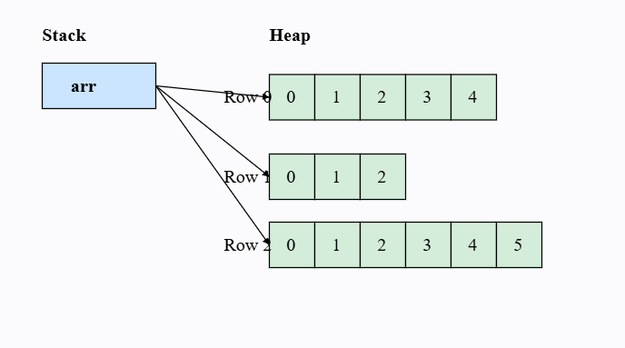

📘 Three-Dimensional Jagged Array (Jagged 3D Array)

🧠 CORE POINT (Memorize This – MOST IMPORTANT)
👉 A jagged 3D array is accessed using three indexes, and each level can have different lengths.
This one line is the entire concept.

🔍 Explain the Core Point (Slow & Clear)

What does “different lengths at each level” mean?
• A jagged 3D array has three levels
• None of these levels are forced to be equal in size
Internally:
• Level 1 stores references to 2D arrays
• Level 2 stores references to 1D arrays
• Level 3 stores the actual values
📌 Every array at every level is created independently,
so their sizes can differ freely.
That is why it is called jagged at multiple levels.

🧩 How Indexing Works (Step-by-Step Thinking)

Example:
int[][][] arr = new int[3][][];

Step 1️⃣: First index
arr[1]
• This does not give values
• It gives one 2D array
So:
👉 First index → selects which 2D array

Step 2️⃣: Second index
arr[1][2]
• This does not give a value
• It gives one 1D array
So:
👉 Second index → selects which 1D array

Step 3️⃣: Third index
arr[1][2][4]
• Now we are inside the 1D array
• This gives the actual value
So:
👉 Third index → selects the value

🔑 Why it is called “Jagged 3D”
• Sizes are not fixed at any level
• 2D arrays can have different sizes
• 1D arrays inside them can also differ
📌 Uneven at level-2 + uneven at level-3
= Jagged 3D array

🧠 One-Line Memory Hook (Very Strong)
👉 First index selects a 2D array, second selects a 1D array, third selects the value — sizes can differ everywhere.
If you remember this line, you will never forget jagged 3D arrays.

❌ What NOT to Remember (Avoid Confusion)
❌ Cubes
❌ Fixed dimensions
❌ Equal sizes
These ideas belong to regular 3D arrays, not jagged ones.

✅ Final Perfect Definition (Exam + Interview Safe)
👉 A jagged 3D array in Java is a 3D array where each level stores references to independently created arrays, allowing different lengths at every level.

2️⃣ Syntax (Core Idea First)

🧠 CORE IDEA
👉 Create arrays level by level, deciding sizes step by step.

Step 1: Create the outermost array
int[][][] arr = new int[3][][];
• Creates 3 references to 2D arrays
• Deeper levels are not created yet

Step 2: Create second-level arrays
arr[0] = new int[2][];
arr[1] = new int[4][];
arr[2] = new int[3][];
• Each 2D array can have a different size

Step 3: Create third-level arrays
arr[0][0] = new int[4];
arr[0][1] = new int[2];

arr[1][0] = new int[3];
arr[1][1] = new int[1];
arr[1][2] = new int[5];
arr[1][3] = new int[2];

arr[2][0] = new int[3];
arr[2][1] = new int[4];
arr[2][2] = new int[3];
📌 Each inner array:
• Is created separately
• Can have any length

3️⃣ How Jagged 3D Array Is Stored in Memory

🧠 CORE IDEA
👉 A jagged 3D array is an array of arrays of arrays, all created independently in heap memory.

Stack Memory
• Stack stores only the reference variable arr
• arr points to heap
arr → heap

Heap Memory (Step-by-Step)

Level 1
• One array storing references to 2D arrays

Level 2
• Each reference points to a 2D array of references

Level 3
• Each reference points to a 1D array of actual values
✔️ Every array is a separate object
✔️ Sizes are not uniform

📌 Important Points to Lock in Memory
✔️ Jagged 3D array is still 3D
✔️ Every level stores references, not values (until last level)
✔️ No level is forced to be equal in size
✔️ Saves memory for uneven real-world data

4️⃣ Example Usage (Understand Indexing Clearly)
arr[1][2][4] = 85;
How Java reads this:
1️⃣ arr[1]
→ select the 2D array at index 1
2️⃣ arr[1][2]
→ select the 1D array at index 2
3️⃣ arr[1][2][4]
→ select index 4 and store value 85

In very simple words:
• First index → which 2D group
• Second index → which 1D group
• Third index → which value
• Stored value → 85

5️⃣ When Should We Use Jagged 3D Arrays?

🧠 CORE IDEA
👉 Use jagged 3D arrays when data is hierarchical and uneven at multiple levels.
Examples:
• Country → State → City
• College → Program → Student
• Company → Department → Team
• Application → Module → Feature

🧠 One-Line Gold Summary (Memorize This)
👉 A jagged 3D array is a 3D array where each level is created independently, allowing different sizes at every level.

Memory representation:
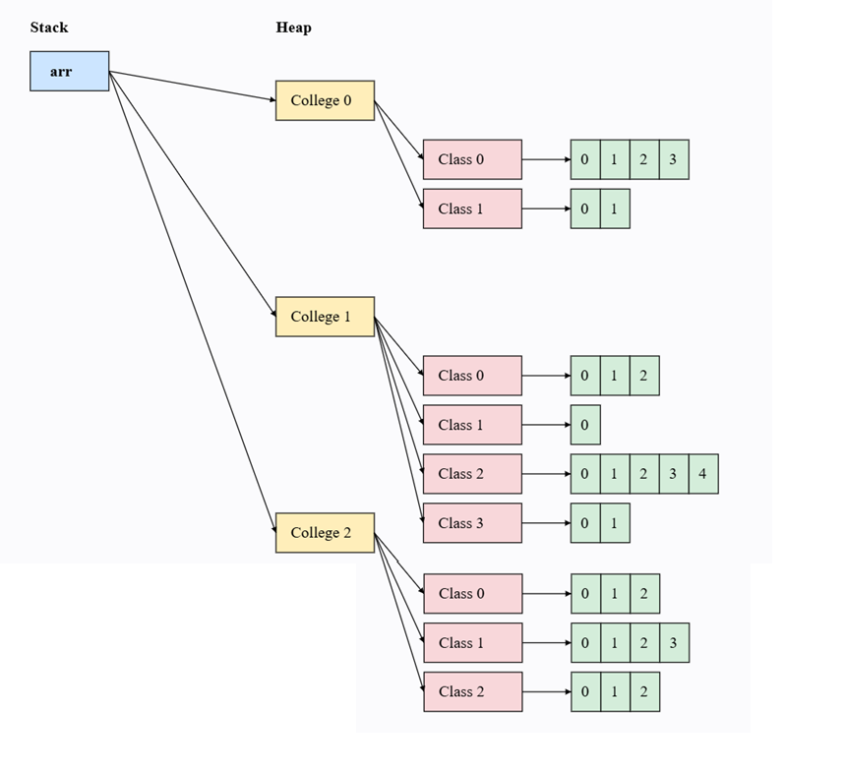

✅ Short Answer (Corrected & Precise)
👉 In C/C++, if an array size is 3 and you try to write at index 3, it will usually NOT throw an error.
Instead, it writes into memory outside the array.
This is called a Buffer Overrun.

🔍 Now Let’s Be Very Precise (Important)

Suppose this C code:
int arr[3];
arr[3] = 50;

What actually happens?
• arr has valid indexes: 0, 1, 2
• arr[3] is outside the array
❌ C does NOT check boundaries
❌ No automatic error is thrown

What happens to the value 50?
⚠️ Important correction to your sentence:
❌ “it will keep it at that size” → NOT correct
✅ Correct understanding:
- The value is written into some nearby memory location
- That memory does not belong to the array
- It may overwrite:
  - Another variable
  - Program data
  - Control information
📌 The array size does NOT increase.

🚨 Why This Is Dangerous (Buffer Overrun)
Because:
• Program continues running
• Memory corruption happens silently
• Program may crash later
• Or behave unpredictably
• Or create a security vulnerability
👉 This unsafe behavior is called Buffer Overrun (or Buffer Overflow).

⚠️ Very Important Interview Line (Memorize This)
👉 In C/C++, accessing beyond array bounds does not increase the array size; it causes memory corruption.

🔐 Contrast with Java (One-Line)
👉 Java stops execution immediately by throwing ArrayIndexOutOfBoundsException.

🧠 Final One-Line Gold Summary
👉 C/C++ allows writing outside array boundaries without error, leading to buffer overrun, whereas Java prevents this at runtime.

✅ Final Verdict on Your Statement
Your statement | Status
No error thrown | ✅ Correct
Value is stored | ⚠️ Partially correct
Stored inside array | ❌ Incorrect
Buffer overrun occurs | ✅ Correct

1️⃣ Arrays Are Objects (Very Important)

Core Concept
👉 Java arrays are objects, not raw memory blocks.
What this means:
• When an array is created, JVM stores:
- Space for values
- Array length information
Example:
int[] arr = new int[3];
Internally, JVM knows:
• This array can store exactly 3 values
• Valid index range is 0 to 2
📌 Length is stored inside the array object.

2️⃣ Runtime Boundary Checking (Main Security Mechanism)

🧠 CORE IDEA
👉 Every array access is checked by the JVM at runtime.
Whenever Java sees:
arr[i]
JVM checks:
0 ≤ i < arr.length

What happens if index is valid?
• JVM allows access
• Value is read or written safely

What happens if index is invalid?
Example:
arr[3] = 50;
• JVM detects:
- Index 3 is outside allowed range
• JVM stops execution immediately
• JVM throws:
ArrayIndexOutOfBoundsException
📌 Memory outside the array is never touched.

3️⃣ Fixed Size (Prevents Memory Abuse)

🧠 CORE IDEA
👉 Array size in Java cannot change after creation.
Why this matters:
• No accidental memory expansion
• No overwriting nearby memory
• Programmer cannot “push” extra values
If more space is needed:
- Create a new array
- Or use ArrayList
📌 Fixed size = controlled memory usage

4️⃣ Automatic Memory Management

🧠 CORE IDEA
👉 Java does not allow manual memory handling.
• Programmer cannot free memory incorrectly
• Programmer cannot access freed memory
• Garbage Collector safely removes unused arrays
📌 This removes:
- Memory leaks
- Dangling pointers
- Unsafe memory access

❌ What Java Completely Prevents
✔️ Writing outside array memory
✔️ Reading garbage values
✔️ Silent memory corruption
✔️ Security holes caused by buffer overrun

✅ Final Perfect Definition (Exam + Interview Safe)
👉 Java secures arrays by treating them as objects, enforcing strict runtime index checking, fixing their size, and managing memory automatically.

